

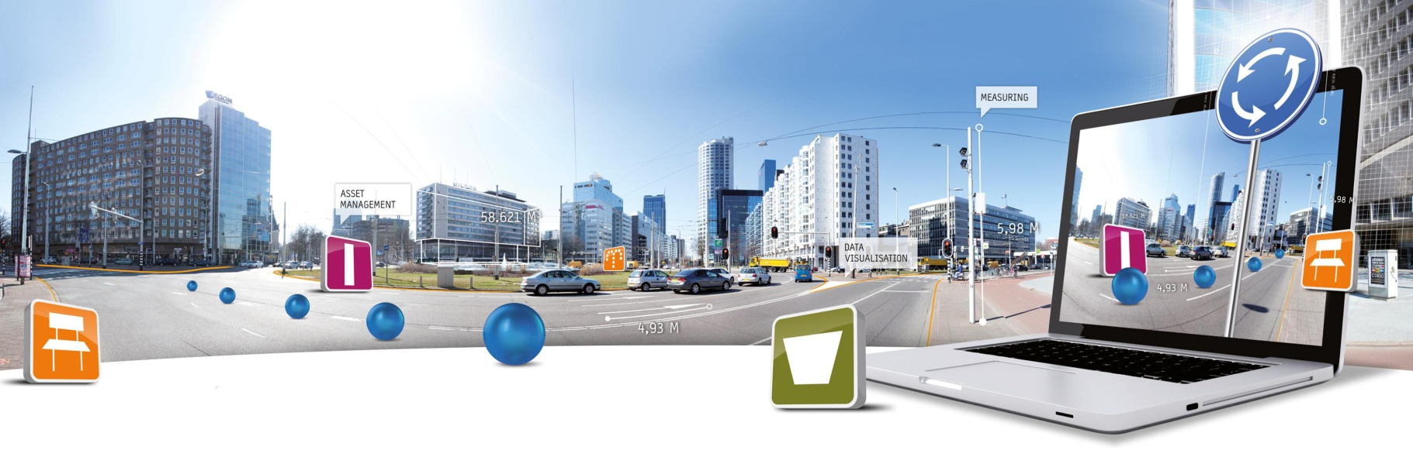

**GlobeSpotter for ArcGIS Desktop User Manual**

Datum: 17 juli 2014

CycloMedia Technology B.V. | **T** +31 (418) 556100 | **E**: [info@cyclomedia.com](mailto:info@cyclomedia.com)

# Index

Index 2

1. Installation 3

2. How to use GlobeSpotter for ArcGIS Desktop 11

2.1 Show Cyclorama images 11

*2.1.1* *Show recent Cyclorama layer* 11

*2.1.2* *Show historical Cyclorama layer* 11

*2.1.3* *Open a Cyclorama image* 12

2.2 Show Vector data 14

2.3 Measurement 15

*2.3.1* *Standaard measurement – Point measurement* 15

*2.3.2* *Standaard measurement – Line / Surface measurement* 17

*2.3.3* *Smart click measurement – Point measurement* 19

*2.3.4* *Smart click measurement – Line / Surface measurement* 21

*2.3.5* *Import a measurement back in a Cyclorama* 23

# 1. Installation

To install GlobeSpotter for ArcGIS Desktop you must perform the following steps:

1. Check if ‘Adobe Flash Player’ is installed on your machine. If ‘Adobe Flash Player’ is not, installed, install ‘Adobe Flash Player’.
2. There are two ways how ‘GlobeSpotter for ArcGIS Desktop’ can be loaded into ArcMap:
   * ‘GlobeSpotter for ArcGIS Desktop’ can be used from a location on disk or network (go to paragraph 3).
   * ‘GlobeSpotter for ArcGIS Desktop’ can be installed in ArcMap (go to paragraph 4).
3. The use of GlobeSpotter for ArcGIS Desktop by a location on disk or network is the easiest method for distribution GlobeSpotter for ArcGIS Desktop across multiple computers.
   * Copy the ‘GlobeSpotter for ArcGIS Desktop’ Add-in file to a disk or network location.
   * Start ArcMap.
   * 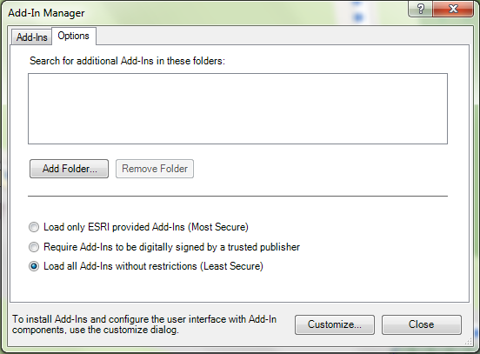Select menu: Customize-> Add-In Manager.
   * Select the Options tab. (Figure 1) .

Figure 1: Add-In manager, Options tab

* + 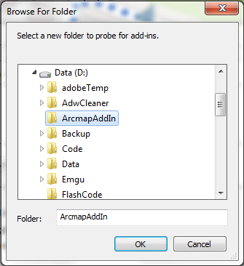Click on the button: <Add Folder...>

Figure 2:Browse to the folder where ‘GlobeSpotter for ArcGIS Desktop’ is located

* + Browse to the folder were ‘GlobeSpotter for ArcGIS Desktop’ is located (Figure 2).
  + Click on the button: <OK>
  + Close the Add-In manager and close ArcMap.
  + Start ArcMap.
  + Select menu: Customize-> Add-In Manager.
  + Check whether GlobeSpotter for ArcGIS Desktop is trusted. (Figure 3)
  + 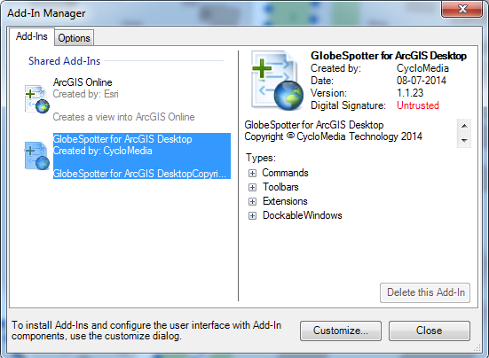If the ‘GlobeSpotter for ArcGIS Desktop’ Add-In is not trusted, close the Add-In Manager, close ArcMap and install the attached certificate (thawte-intermediate-ca.cer).

Figure 3: Add-In Manager, Add-Ins tab, check GlobeSpotter for ArcGIS Desktop is trusted

* + To install the certificate, you must perform these steps:
    - 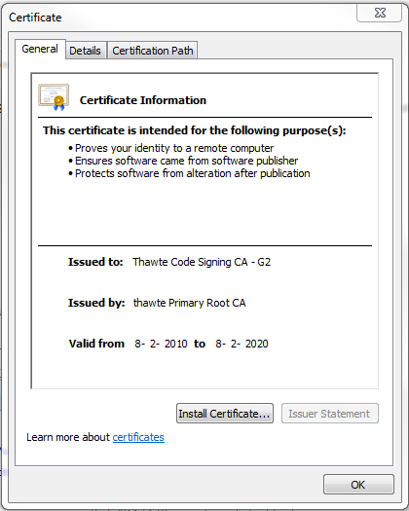Install the thawte-intermediate-ca.cer by double-click the certificate (Figure 4).
    - Click on <Install Certificate...> and the installation wizard for the certificate is started (Figure 5).

Figure 4: Install the Thawte-intermediate-ca

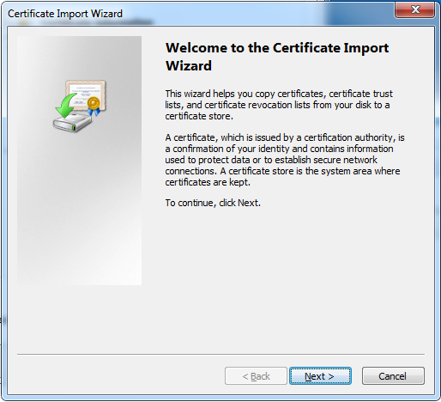

Figure 5: Certificate import wizard

* + - 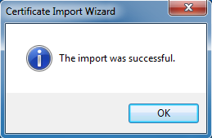Click: <Next>, <Next>, <Finished> and the certificate is installed ().
  + Start ArcMap.

Figure 6: The import was successful

* + Select menu: Customize -> Add-In manager
  + 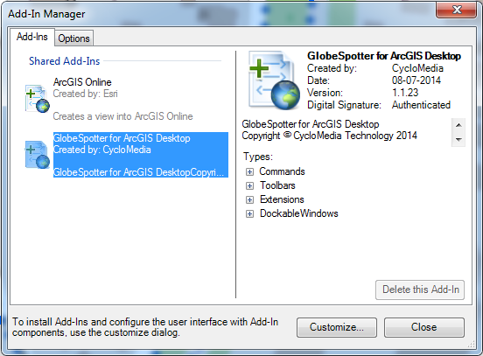Make sure ‘GlobeSpotter for ArcGIS Desktop’ is now trusted ().
  + You may proceed to paragraph .

1. To install ‘GlobeSpotter for ArcGIS Desktop’ in ArcMap you must follow these steps:

Figure 7: Add-In Manager, Add-Ins tab, Check GlobeSpotter for ArcGIS Desktop is Authenticated.

* + If you have installed a previous version of ‘GlobeSpotter for ArcGIS Desktop’, first delete the previous version:
    - Start ArcMap.
    - Customize -> Add-In Manager (Figure 9)
    - Select the ‘GlobeSpotter for ArcGIS Desktop’ Add-In and click on the button: <Delete this Add-In>.
    - Close the Add-In Manager and close ArcMap.
  + 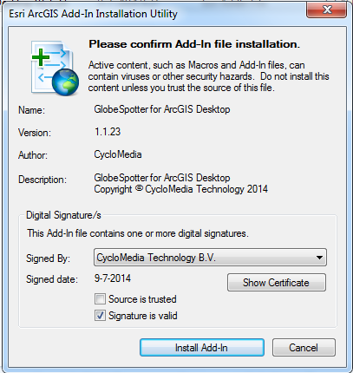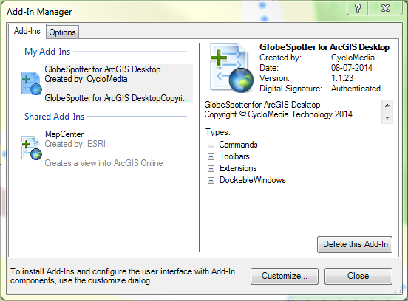Double-click the ‘GlobeSpotter for ArcGIS’ Desktop Add-In and check whether the Add-In is trusted.

Figure 8: GlobeSpotter for ArcGIS Desktop Add-In installation (not trusted)

Figure 9: Add-In Manager, Add-Ins tab, Delete previous version of ‘GlobeSpotter for ArcGIS Desktop’

* + If the ‘GlobeSpotter for ArcGIS Desktop’ Add-In is not trusted, Click <Cancel> and install the attached certificate. (thawte-intermediate-ca.cer).
  + To install this certificate, check step: XIII from paragraph 3).
  + 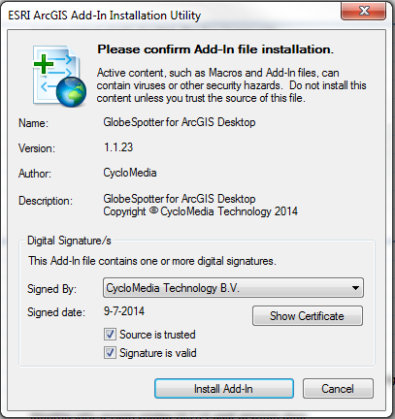Double-click the ‘GlobeSpotter for ArcGIS Desktop’ Add-In again and check whether the Add-In is now trusted. (Figure 10)
  + Select <Install Add-In> to install the Add-In.

Figure 10: ‘GlobeSpotter for ArcGIS Desktop’ Add-In installation (trusted)

* + Start ArcMap.

1. If you start ArcMap for the first time after installing the ‘GlobeSpotter for ArcGIS Desktop’ Add-In, you get the agreement form (Figure 12).
2. 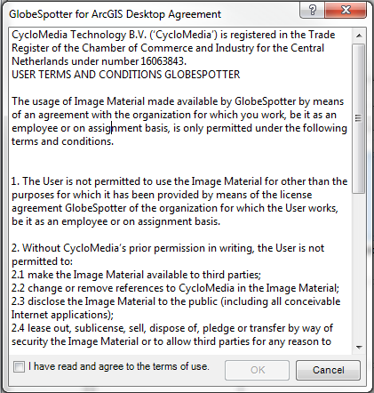Checkmark: ‘I have read and agree to the terms of use’ and click on ‘OK’.

Figure 11: Agreement form

1. 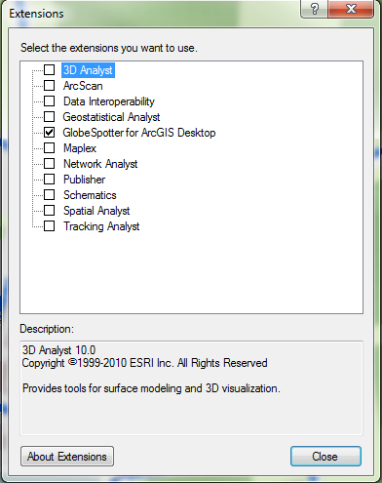If you do not get the agreement form, select the menu: Customize -> Extensions. (Figure 11).
2. Checkmark: ’GlobeSpotter for ArcGIS Desktop’ extension and you will now get the ‘GlobeSpotter for ArcGIS Desktop’ Agreement. You get the agreement only once.

Figure 12: Extensions menu, select the extension ‘GlobeSpotter for ArcGIS Desktop’

1. Close the extensions form.
2. Select the GlobeSpotter toolbar: Customize -> toolbars -> GlobeSpotter (Figure 14).
3. Select the ‘GlobeSpotter for ArcGIS Desktop’ icon (Figure 13) of the Cyclorama toolbar. You get the ‘GlobeSpotter for ArcGIS Desktop’ form now.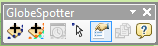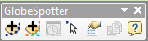

Figure 13: The selected 'GlobeSpotter for ArcGIS Desktop' icon

Figure 14: GlobeSpotter toolbar

1. 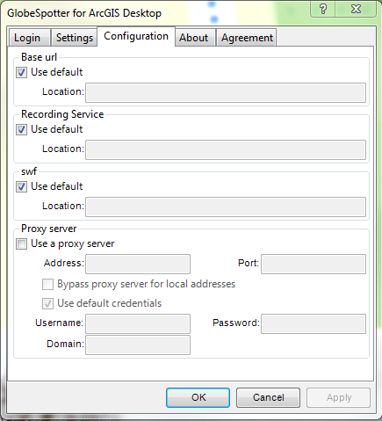Select the configuration tab (Figure 15)
2. If you use a proxy server, you can checkmark: ‘use a proxy server’ and enter the data about your proxy server.

Figure 15: ‘GlobeSpotter for ArcGIS Desktop’ form, Configuration tab

1. If you are using a local installation, uncheck the base url and the swf url and fill in the correct urls.
2. Select the Login tab (Figure 16).
3. Enter your username and password and press: <Apply>
4. If you see ‘Login Successfully’, you are logged in.
5. 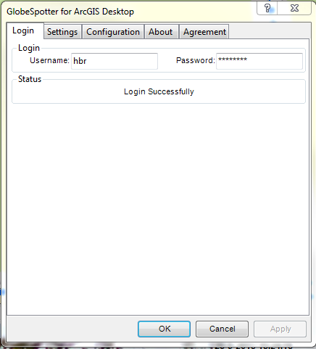Now you are ready for use the ‘GlobeSpotter for ArcGIS Desktop’ Add-In.

Figure 16:’GlobeSpotter for ArcGIS Desktop’ form, Login tab

# 2. How to use GlobeSpotter for ArcGIS Desktop

## 2.1 Show Cyclorama images

### *2.1.1 Show recent Cyclorama layer*

You have to do these steps to show the recent Cyclorama layer in the map:

1. 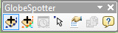Select in the GlobeSpotter toolbar: ‘Add recent cyclorama layer’(Figure 17).
2. 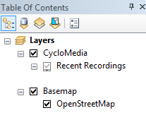In the 'Table of contents – layers’ screen appears a 'CycloMedia - Recent Recordings' layer (Figure 18).

Figure 17: The selected 'Add Recent Cyclorama Layer’ icon

1. Zoom in on the map and if you have reached a zoom level of 1:2000, you will see dots on the map. (With the condition that there are recordings in that area)

Figure 18: The CycloMedia - Recent Recordings Layer

### *2.1.2 Show historical Cyclorama layer*

You have to do these steps to show the historical Cyclorama layer in the map:

1. 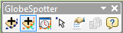Select in the GlobeSpotter toolbar: ‘Add historical cyclorama layer’(Figure 19).

Figure 19: The selected 'Historical Cyclorama Layer' icon

1. 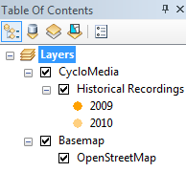In the 'Table of contents – layers’ screen appears a 'CycloMedia – Historical Recordings' layer (Figure 20).
2. Zoom in on the map and if you have reached a zoom level of 1:2000, you will see dots on the map. (With the condition that there are recordings in that area)

Figure 20: The CycloMedia - Historical Recordings Layer

1. 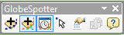The date range of the recordings can be changed with the ‘CycloMedia Recording History’ form. Select the ‘CycloMedia Recording History’ form in the GlobeSpotter toolbar. (Figure 21)

Figure 21: The selected CycloMedia recording History form

1. You can change the date range in this form. (Figure 22)

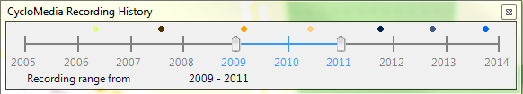

Figure 22: CycloMedia Recording History

### *2.1.3 Open a Cyclorama image*

You have to do these steps to open a Cyclorama image:

1. Select the ‘Settings’ tab of the GlobeSpotter for ArcGIS Desktop form. (Figure 23)
2. Select the coordinate system which the viewer must use.
3. Select the maximum cyclorama viewers which can be opened at the same time. The default value is three viewers.
4. Some areas are driven with additional cameras. These detailed images can be made visible with the: ‘show detail images’ checkmark.
5. Press <Apply> and the changes take effect.
6. Select the ‘Open location tool’ in the Cyclorama toolbar (Figure 24).
7. 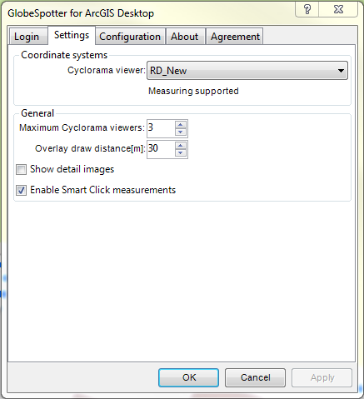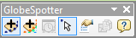Click on a dot and the corresponding cyclorama opens (Figure 25).

Figure 23: Cyclorama viewer tab

Figure 24: The selected 'Open location tool'

1. Click on another dot and a second corresponding cyclorama opens (Figure 25).
2. Right click on the Recent or Historical Recording layer and the feature layer context menu appears. (Figure 27).
3. 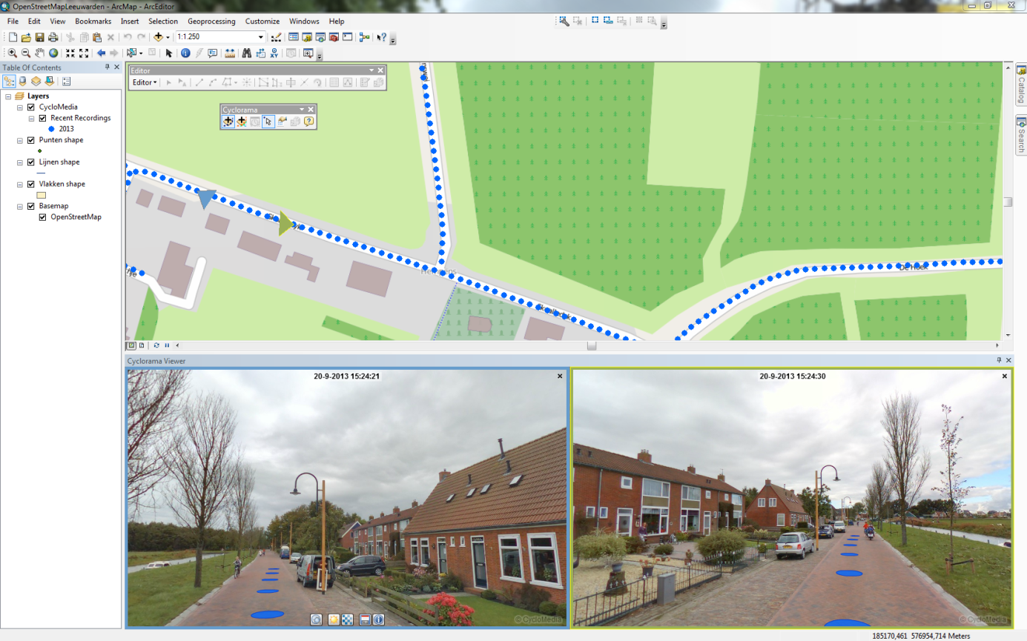With The 'Show in Cyclorama' button, the recording points in the Cyclorama can be turned on or off.

Figure 25: GlobeSpotter for ArcGIS Desktop with 2 open cycloramas

## 2.2 Show Vector data

1. Add vector data to the map (Points, lines or polygons), vector data can be like:
   * Shape files
   * ArcSDE
   * Personal MDB
   * File GDB
2. 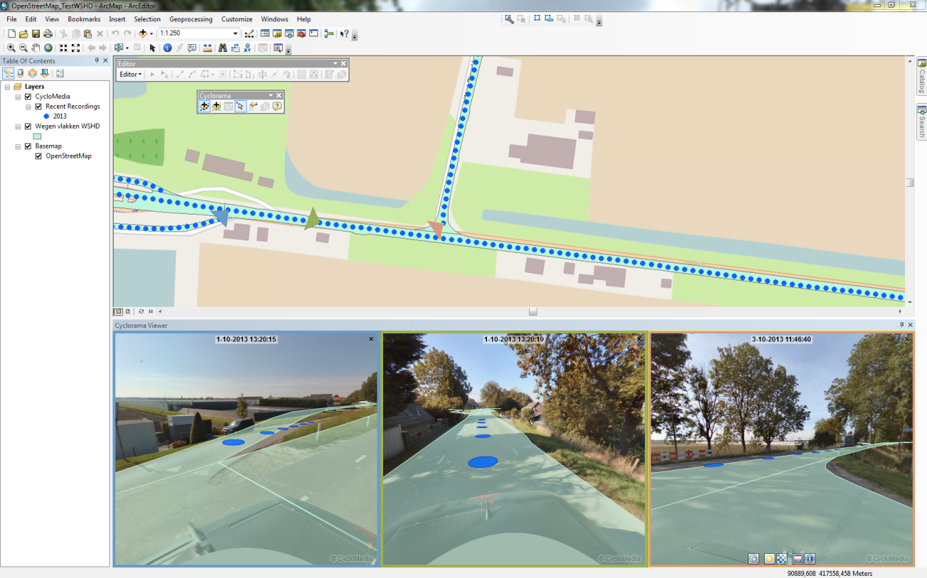Open a cyclorama (Figure 26)

Figure 26: Show vector data

1. 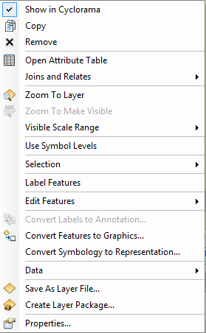Right click on the vector layer and the feature layer context menu appears (Figure 27)
2. With The 'Show in Cyclorama' button, the vector layer in the cyclorama can be turned on and off.
3. The distance around the images which the vector layer data is included in the cyclorama can be set in the ‘GlobeSpotter for ArcGIS Desktop – Settings’ menu (Overlay draw distance[m]) (Figure 23). The default distance is 30 meters.

Figure 27: feature layer context menu

## 2.3 Measurement

Measurements are stored in vector data layers. Point, line or surface measurements are stored in point, line or polygon vector data layers. The following sections explain in detail the various types of measurements:

* + ***2.3.1 Standaard measurement – Point measurement***
  + ***2.3.2 Standaard measurement – Line / Surface measurement***
  + ***2.3.3 Smart click measurement – Point measurement***
  + ***2.3.4 Smart click measurement – Line / Surface measurement***

### *2.3.1 Standaard measurement – Point measurement*

1. Add a point vector data layer to the map where you want to add the measurement.
2. Open two or more images which the object is visible what should be measured.
3. 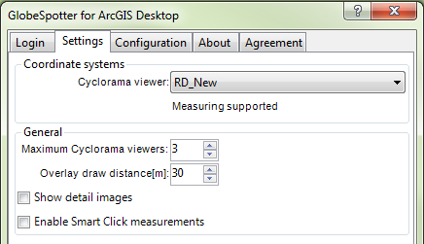Disable smart click measurement in the ‘GlobeSpotter for ArcGIS Desktop – Settings’ menu. (Figure 28)
4. 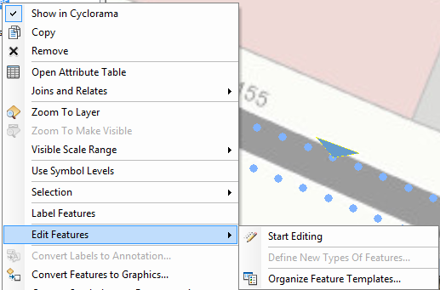Right click on the point vector layer and select: ‘Edit Features -> Start Editing’

Figure 28: Disable smart click measurement

(Figure 29)

Figure 29: Edit features

1. 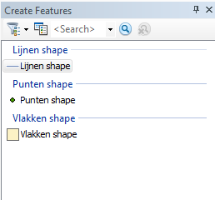Select the point layer in the Create Features form to start a point measurement. (Figure 30)
2. 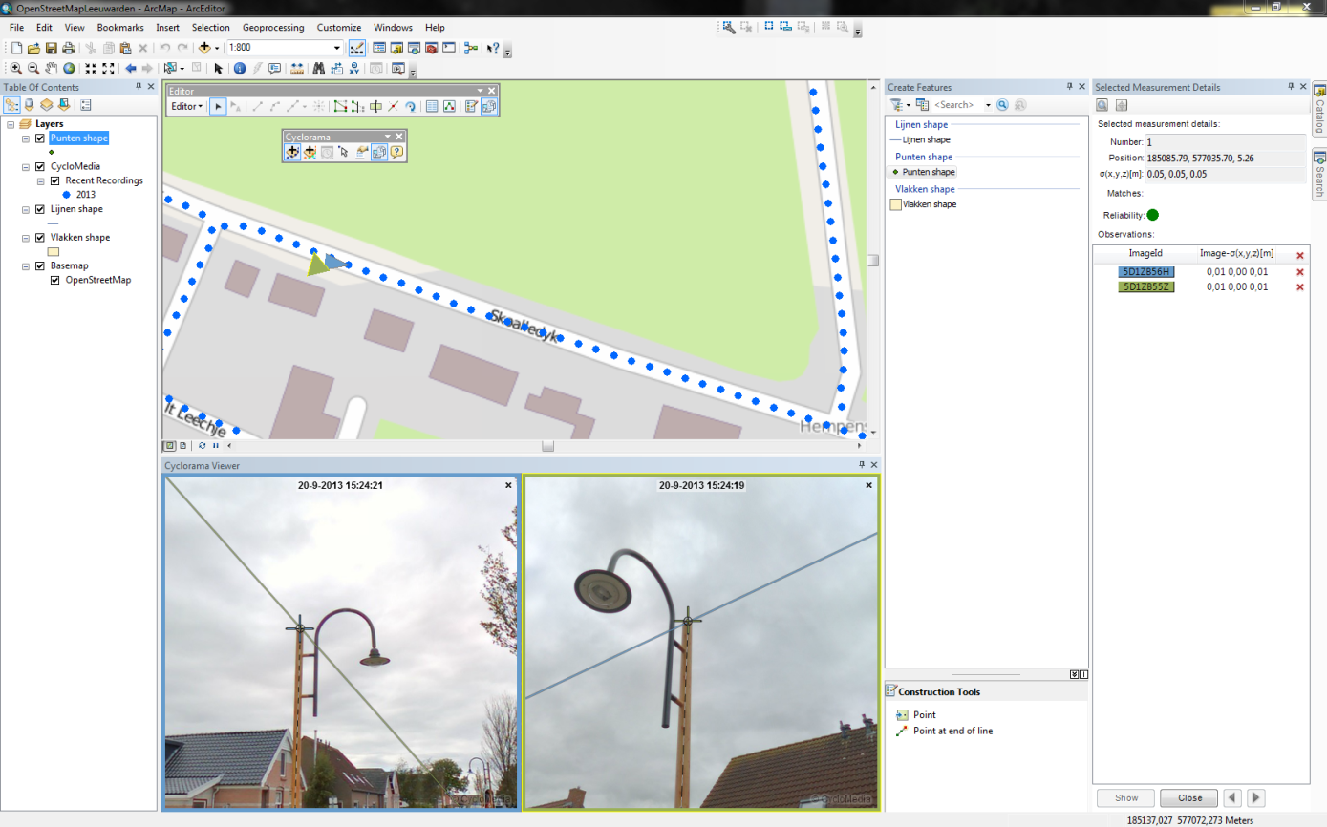Select the point you want to measure in the first image.

Figure 30: Create Features

1. Select the point you want to measure in the second image. (Figure 31)

Figure 31: Point measurement (no smart click)

1. 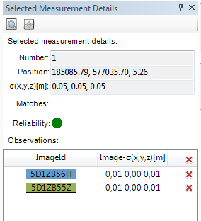The selected measurement details form contains information about the measurement. (Figure 32)

Figure 32: Selected measurement details form

1. 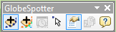The GlobeSpotter toolbar contains a icon for make the selected measurement details form visible / invisible. (Figure 33)

Figure 33: The selected measurement details icon

1. It is possible now for remove observation points or to add more observation points.
2. If you want to add more observation points, open a new image and select in that image the point you want to measure.
3. 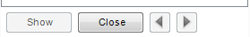If you are finished, Click the <Close> button down the ‘Selected Measurement Details’ form. (Figure 34)

Figure 34: The selected measurement details buttons

1. The measurement point is added now, if you want, you can measure more points at the same way.
2. 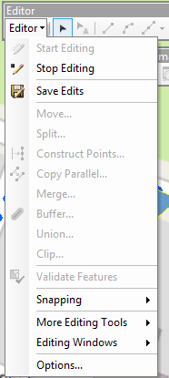If you are finished with measurement, you can save the edits to the vector layer. (Figure 35)

Figure 35: Menu for save and stop editing

### *2.3.2 Standaard measurement – Line / Surface measurement*

1. Add a line or a polygon vector data layer to the map where you want to add the measurement.
2. Open two or more images which the object is visible what should be measured.
3. Disable smart click measurement in the GlobeSpotter for ArcGIS Desktop Options – Measurement menu. (Figure 28)
4. Right click on the line or polygon vector layer and select: ‘Edit Features -> Start Editing’ (Figure 29)
5. Select the line or polygon layer in the Create Features form to start a line or a surface measurement. (Figure 30)
6. Select the first point you want to measure in the first image.
7. 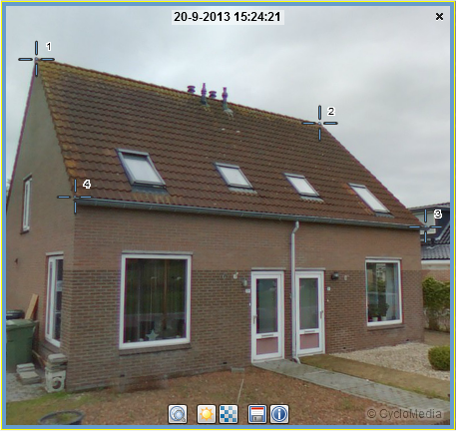Then you select the second and the third point you want to measure, until you have done all the points you want to measure in the first image. (Figure 36)
8. Then you select step by step all the points of the measurement in the second image. (Figure 39)

Figure 36: select step by step all the points in the first image

1. 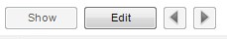The measurement is now complete. If you want to edit some measurement points, click the <Edit> button down the ‘Selected Measurement Details’ form. (Figure 37)
2. You can now move through the measurement points with the ‘<’ and the ‘>’ buttons.

Figure 37: The edit button for edit the measurement

1. You can add or remove observation points for a selected measurement. (Figure 32)
2. If you want to go back to the measurement for add more measurement points or to finished measurement. Click the <Close> button down the ‘Selected Measurement Details’ form. (Figure 34)
3. 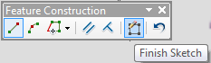Click on the "finish sketch" button of the "Feature Construction" menu to close the measurement. (Figure 38)

Figure 38: Feature Construction menu

1. 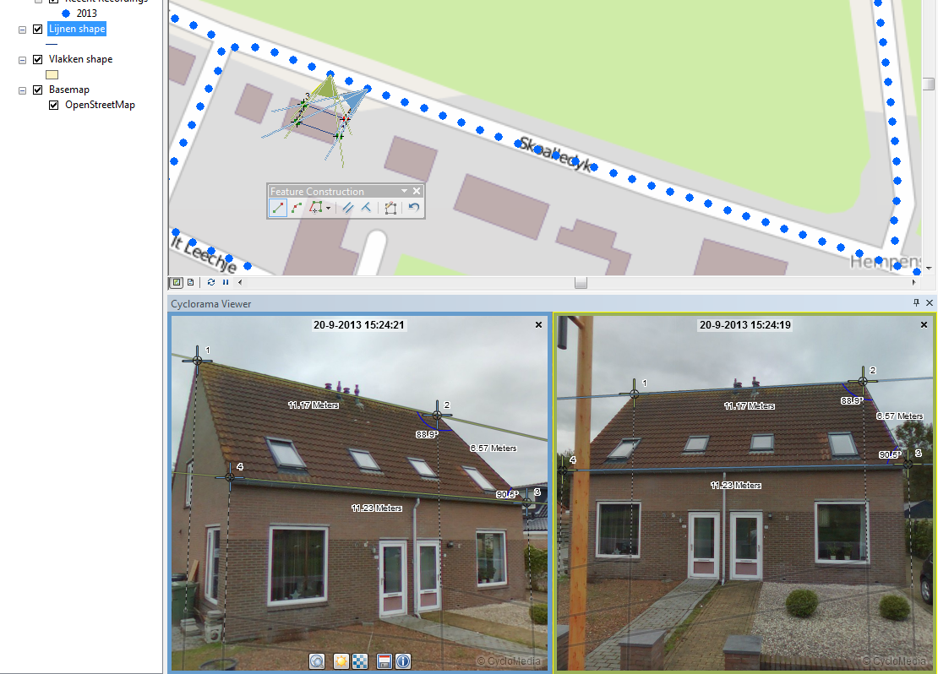 If you are finished with measurement, you can save the edits to the vector layer (Figure 35)

Figure 39: After select the points in the second image, the measurement is complete

### *2.3.3 Smart click measurement – Point measurement*

1. Add a point vector data layer to the map where you want to add the measurement.
2. Open a image which the object is visible what should be measured.
3. 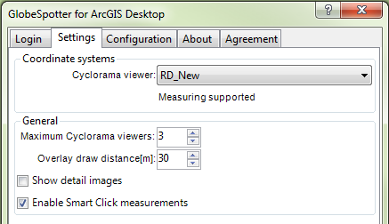Enable smart click measurement in the ‘GlobeSpotter for ArcGIS Desktop – Settings’ menu. (Figure 40)

Figure 40: Enable smart click measurement

1. Right click on the point vector layer and select: ‘Edit Features -> Start Editing’ (Figure 29)
2. Select the point layer in the Create Features form to start a point measurement. (Figure 30)
3. Select the point you want to measure in the image. (Figure 41)

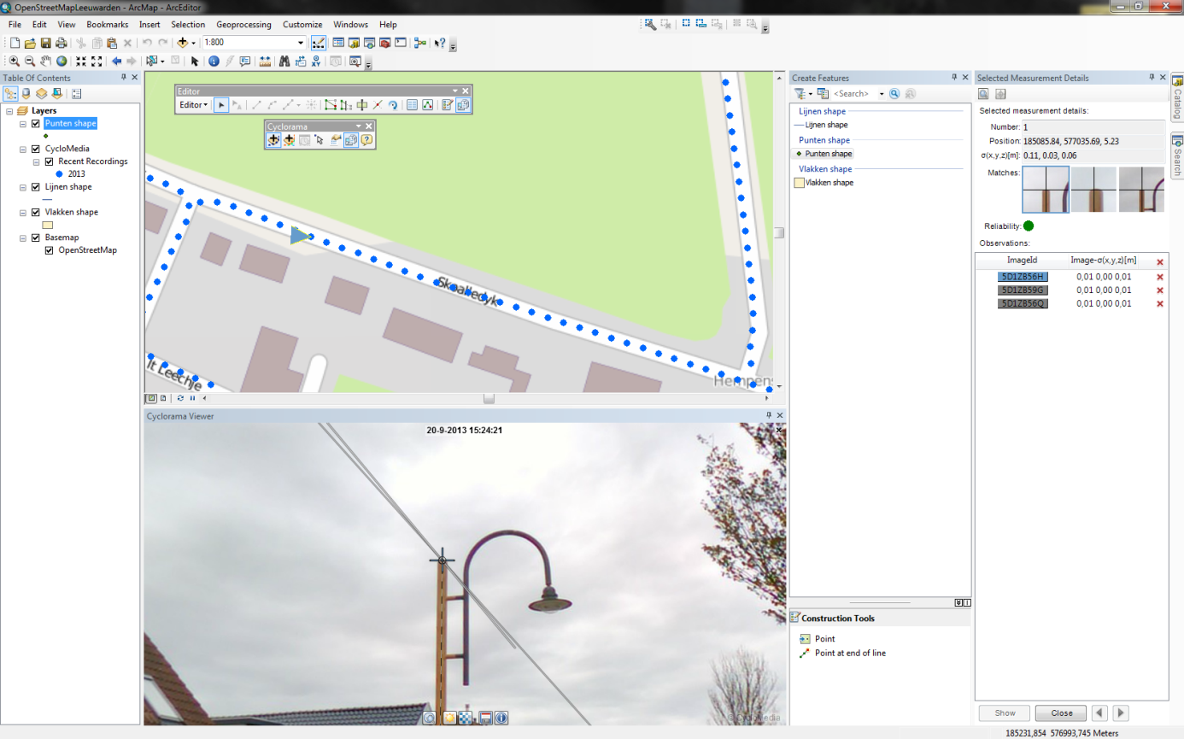

Figure 41: Point measurement (smart click)

1. 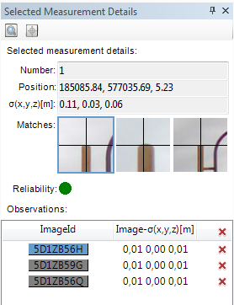The selected measurement details form contains information about the measurement. (Figure 42)

Figure 42: Selected Measurement Details form (Smart click)

1. 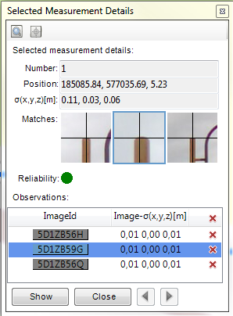You can check the other images which are found by smart click by clicking on the image and click on <Show>. (Figure 43)
2. It is now possible to change correspondence points found by smart click.

Figure 43: Check results found by smart click

1. It is also possible for add or remove observation points.
2. If you want to add more observation points, open a new image and select in that image the point you want to measure.
3. If you are finished, Click the <Close> button down the ‘Selected Measurement Details’ form. (Figure 43)
4. The measurement point is now added, if you want, you can now measure a second point at the same way.
5. If you are finished with measurement, you can save the edits to the vector layer. (Figure 35)

### *2.3.4 Smart click measurement – Line / Surface measurement*

1. Add a line or a polygon vector data layer to the map where you want to add the measurement.
2. Open a image which the object is visible what should be measured.
3. Enable smart click measurement in the ‘GlobeSpotter for ArcGIS Desktop – Measurement’ menu. (Figure 40)
4. Right click on the line or polygon vector layer and select: ‘Edit Features -> Start Editing’ (Figure 29)
5. Select the line or polygon layer in the Create Features form to start a line or a surface measurement. (Figure 30)
6. Select the first point in the image which you want to measure. (Figure 44)

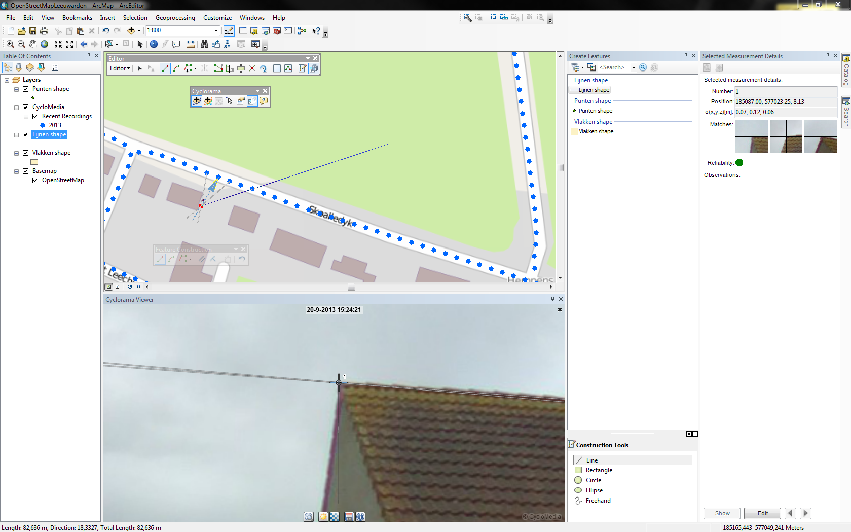

1. The selected measurement details form contains information about the measurement.

Figure 44: Line or polygon measurement after adding first point

(Figure 42)

1. If you want to edit or check some observation points, first click on the <Edit> button.
2. You can check the other images which are found by smart click by clicking on the image and click on <Show>. (Figure 43)
3. It is now possible to change correspondence points found by smart click.
4. It is also possible for add or remove observation points.
5. If you want to add more observation points, open a new image and select in that image the point you want to measure.
6. If you want to add more measurement points, first close the measurement point.
7. Then you select the second and the third point you want to measure, until you have done all the points you want to measure.
8. For each measurement point that you add, you must first check if it is good.
9. Click on the "finish sketch" button of the "Feature Construction" menu to close the measurement. (Figure 38)
10. If you are finished with measurement, you can save the edits to the vector layer (Figure 35)

### *2.3.5 Import a measurement back in a Cyclorama*

You have to do these steps to import a measurement back in a Cyclorama:

1. 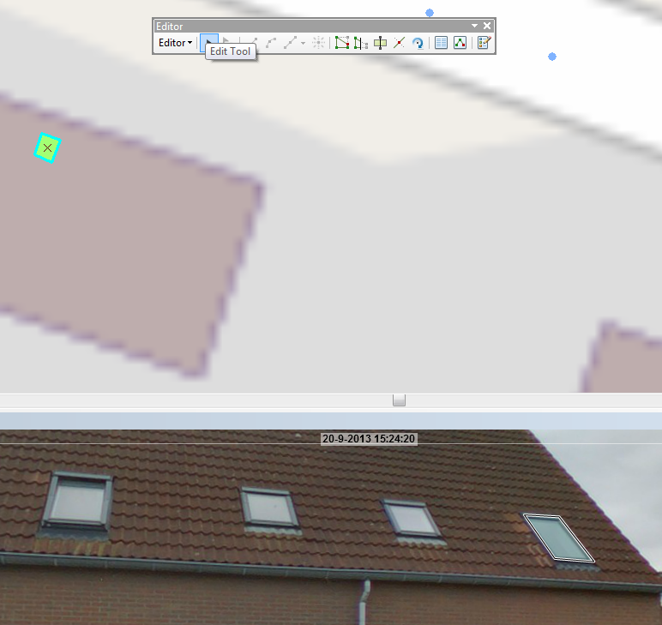Select the 'Edit tool’ button in the editor menu and a measurement can now be selected for import back into a cyclorama. (Figure 45)

Figure 45: Editor menu

1. 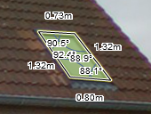Select a feature and the Measurement is placed back in the cyclorama. (Figure 46)

Figure 46: Measurement in cyclorama

1. Click on the feature and on the right mouse button and select in the menu 'Edit Vertices' to edit the measurement in the cyclorama. (Figure 47)
2. 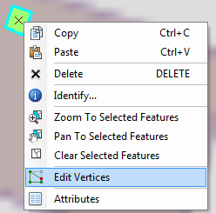It is now possible to edit the measurement in the cyclorama or in the map.

Figure 47: Select Edit Vertices

1. If you want to edit a measurement point in the cyclorama, select that point in the map.
2. 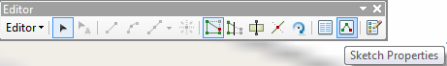Click in the ‘Editor’ menu on the ‘Sketch Properties’ button for view the values of the measurement points. (Figure 48)

Figure 48: Editor menu - Sketch properties

1. 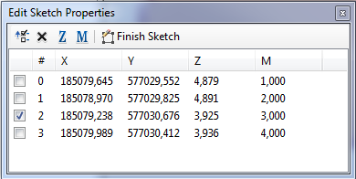You can change the measurement values by selecting a point. The M value is the reference to the number of that point in the cyclorama . (Figure 49)

Figure 49: Edit Sketch properties